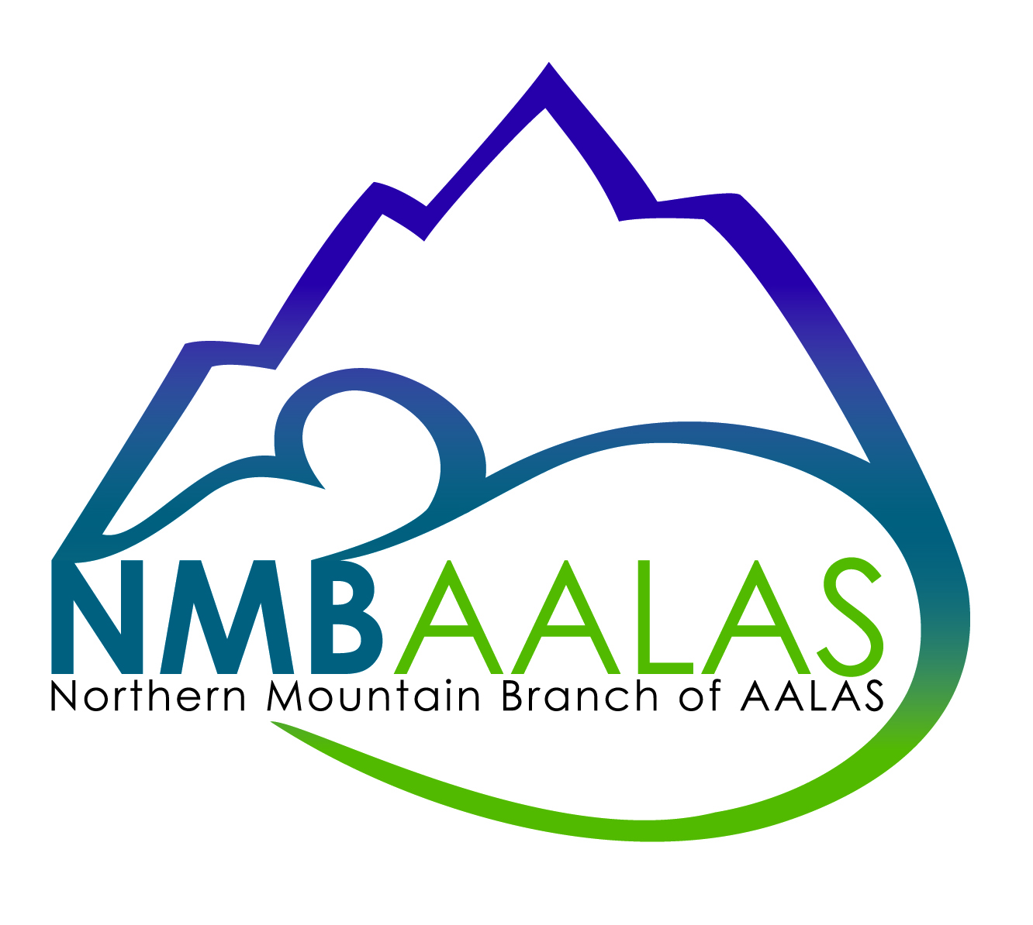 Northern Mountain Branch
American Association of Laboratory Animal Science
2018 MEMBERSHIP APPLICATION
 | New Member |  | Renewal Member
Type of Membership (check one)
____Individual $20.00 | (Includes membership, quarterly e-newsletter, invitation to all local/regional meetings, and optional membership to the AALAS Learning Library)
____Vendor – Basic $150.00 | (Includes two individual memberships per company, a vendor table at all meetings, and 1 business card advertising in newsletter )
____Vendor – Advanced $250.00 | (Includes two individual memberships per company, a vendor table at all meetings, business card advertising, and up to full page advertising in newsletter)
NMB-EN: 03-0365292
Name: ______________________________________________
Position/Title: ______________________________________________
Employer: ______________________________________________
Business Address: ______________________________________________
Business Phone: ______________________________________________
E-mail Address: ______________________________________________

Certification Level: □ ALAT □ LAT □ LATG □ CMAR Registered? □
Credentials: □ AAS □ AS □ BS □ BA □ MS □ DVM □ ACLAM Cert
Are you a National Member? □ Yes Membership # ___________________
□No
Would you like to join the AALAS Learning Library (ALL)? □ Yes (branch covers fees)
□ No
Signature of Applicant: __________________________________________

Please mail to: Joanne Huyler 36 Depot Rd. Hatfield, MA 01038
Make checks payable to: Northern Mountain AALAS

